Git Workflow - Git GUI Workflow

Open Git GUI
# Source: ScreenShots Source: Provided by: [Persons Table -> ID Column: 1, Name_En Column: Motasem Essam] -> Tool: [Lightshot Program] -> From [Operating System: Windows] on [2/19/2026]
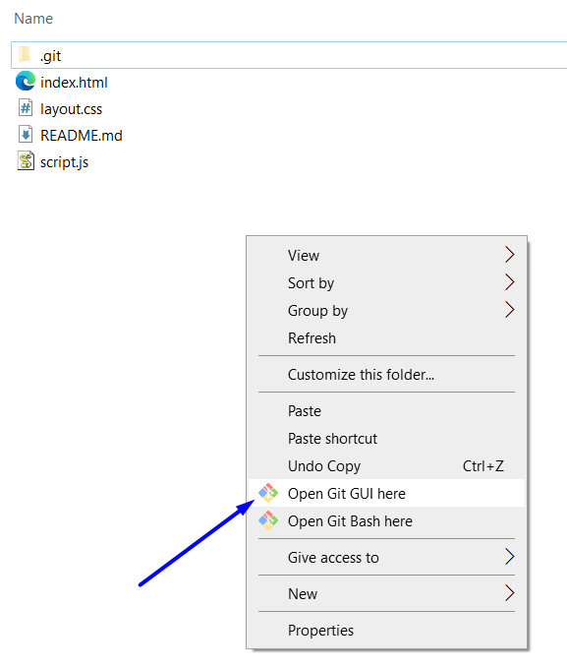
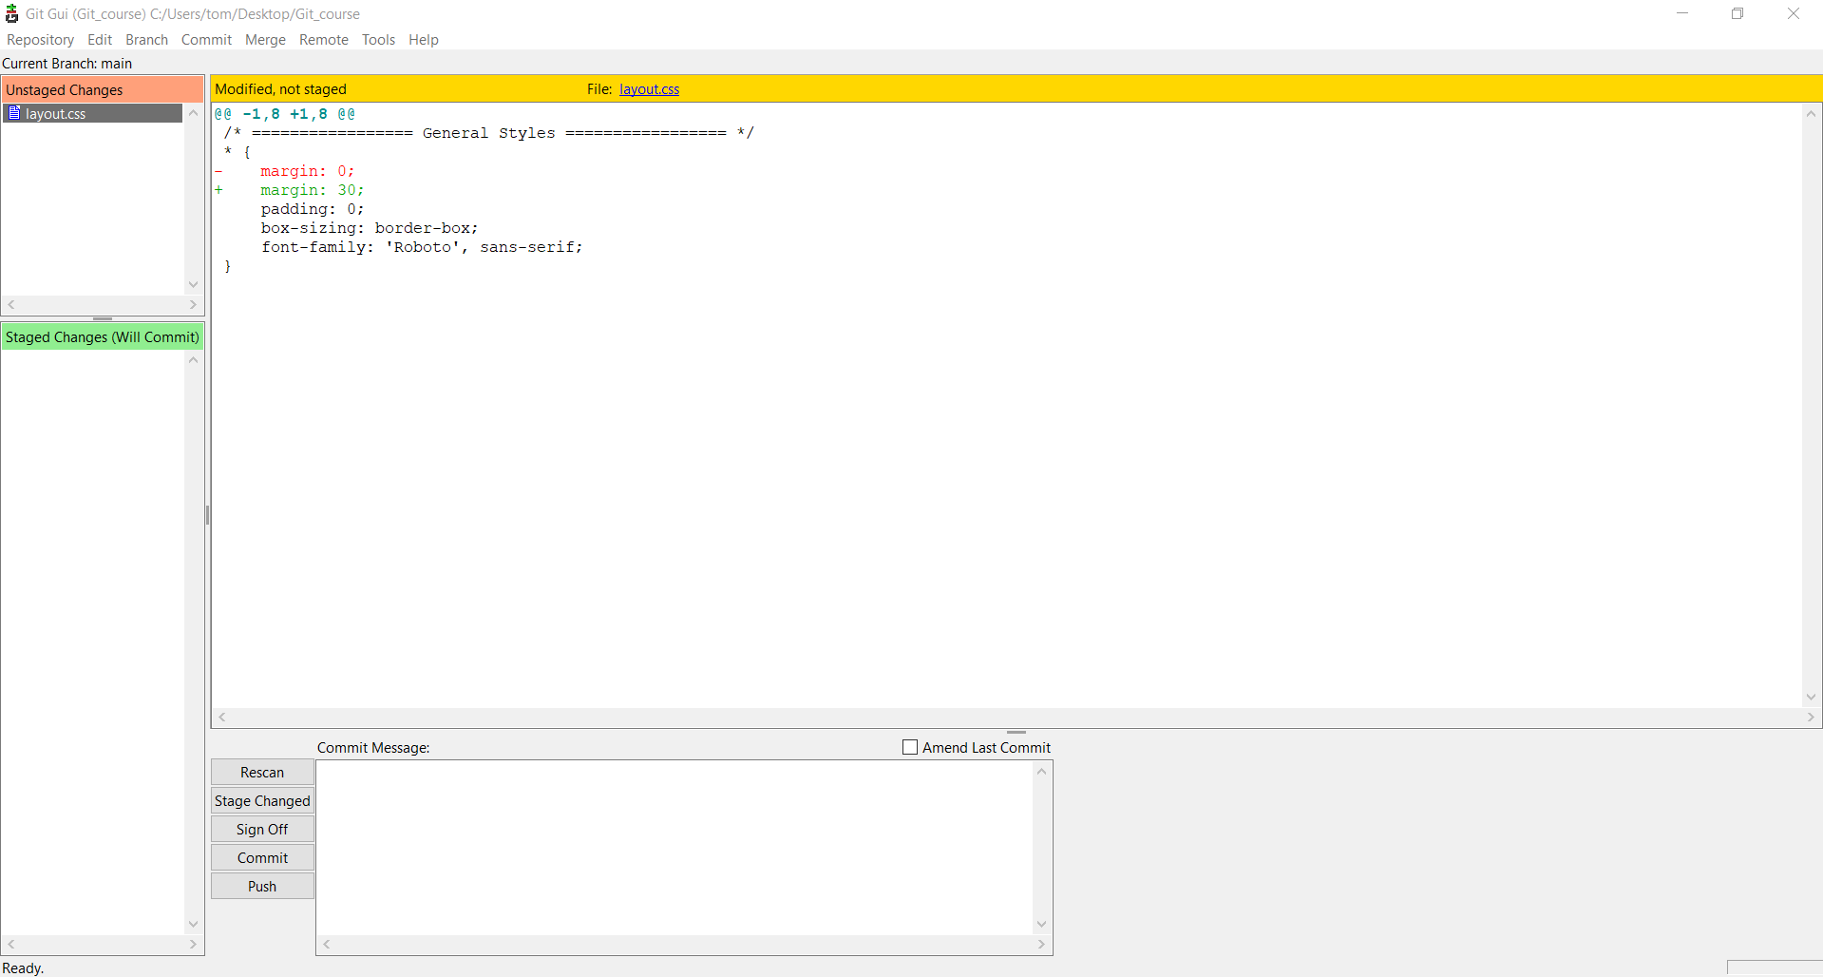

From staging to Workspace
# Source: ScreenShots Source: Provided by: [Persons Table -> ID Column: 1, Name_En Column: Motasem Essam] -> Tool: [Lightshot Program] -> From [Operating System: Windows] on [2/19/2026]
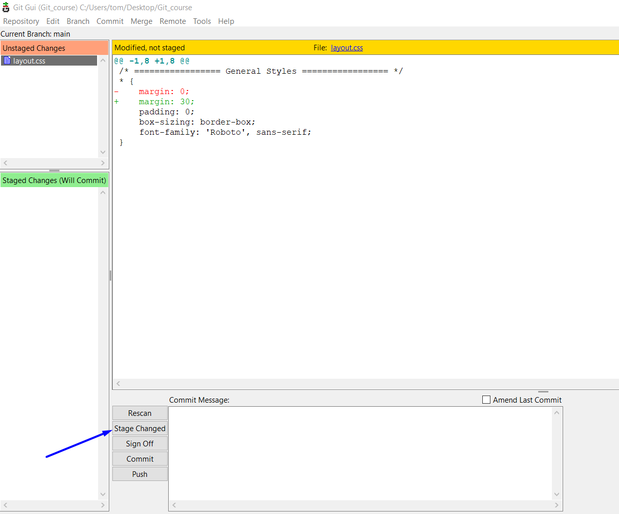
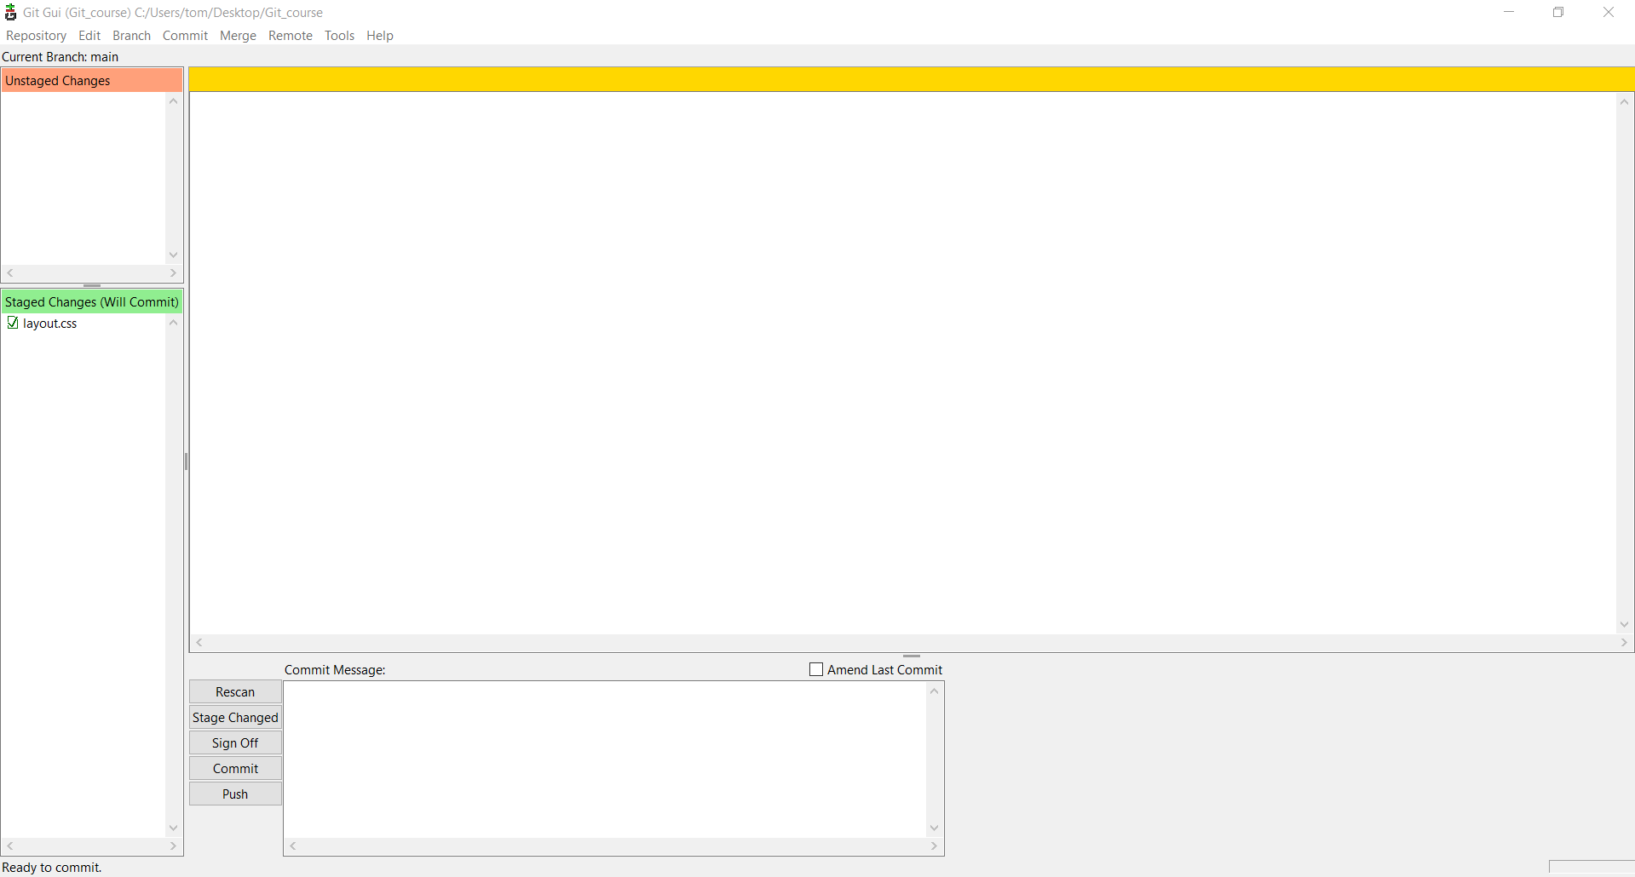

From staging to Local repository
# Source: ScreenShots Source: Provided by: [Persons Table -> ID Column: 1, Name_En Column: Motasem Essam] -> Tool: [Lightshot Program] -> From [Operating System: Windows] on [2/19/2026]
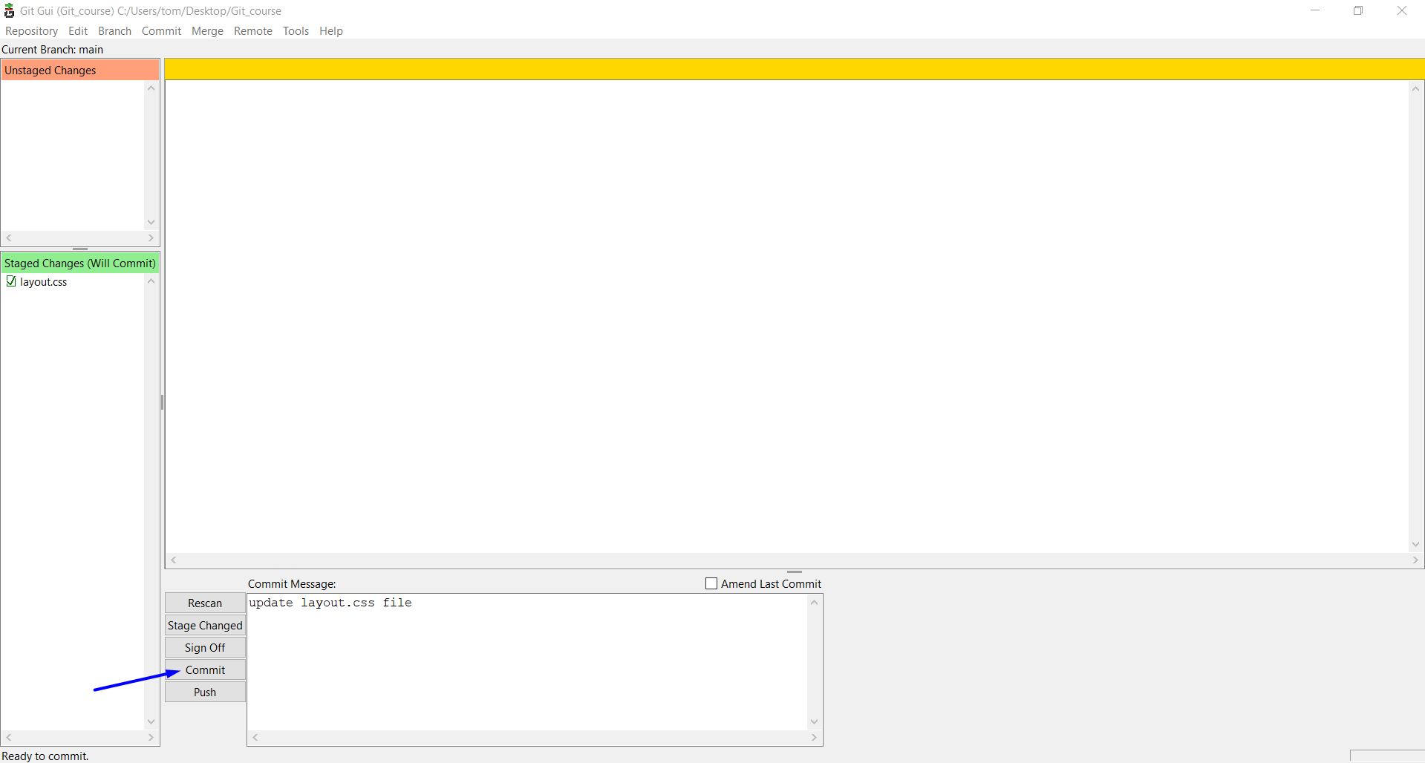

From Local repository to Remote repository
# Source: ScreenShots Source: Provided by: [Persons Table -> ID Column: 1, Name_En Column: Motasem Essam] -> Tool: [Lightshot Program] -> From [Operating System: Windows] on [2/19/2026]
